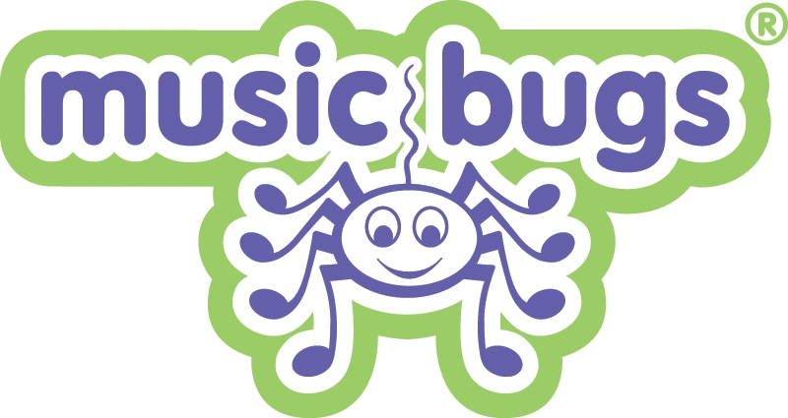

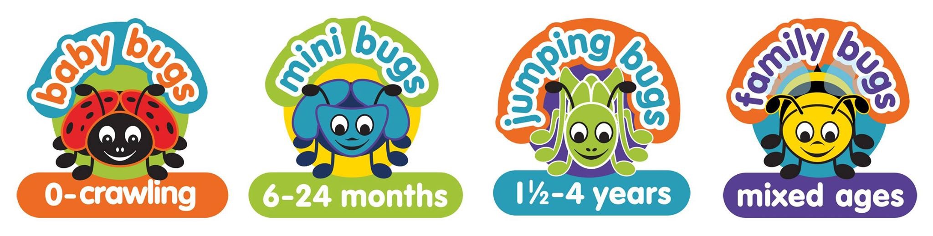

Welcome to Music Bugs North Down
Thank you for your enquiry about Music Bugs classes in North Down and the surrounding area. We hope to be able to welcome you to our sessions very soon. To view our class schedule, please visit: www.musicbugs.co.uk/northdown/classes and book online here: https://bookwhen.com/musicbugsnorthdown.
If you are joining Music Bugs for the first time you are welcome to book ‘3 consecutive classes for £13’ (cost of a regular class is £5.50).
Please note: All trial sessions are offered subject to availability and must be pre-booked by contacting Lynda-Jane at: northdown@musicbugs.co.uk
Enrolment
If you wish to enrol after your trial session/s, payment is required upfront for the remainder of the term and the price is £5.50 per session.
Siblings under 12 months are free (but only count as one place) and over 12 months the fee is £4.13. Discounts are available for childminders and multiples so please get in touch if you require further information.
I am also available to bring something extra special to your child’s birthday party or run sessions in Nurseries and at Parent and Toddler Groups.
Social Media
Please come and join us on the Music Bugs North Down Parent and Carers Facebook group for the latest news, competitions, photos and get to know your fellow Bugs families: https://www.facebook.com/groups/988543287972376/
If you haven't had a chance to give my page a 'like' on Facebook please click here: https://www.facebook.com/MusicBugsNorthDown/ and tag me in on Instagram @musicbugsnorthdown.
Health and Safety
Please note that you are responsible for your child's safety at all times. Please ensure that you are selecting age-appropriate instruments for young babies and that your child is using all props safely. We use sterilising wipes between every class to clean any instruments that have gone into children’s mouths (we know it is impossible to stop them chewing things!) so if your child has taste-tested any of the props please hand them back to your class leader at the end of the class instead of returning them to the tubs so that they can be cleaned. Please also inform us of any spillages.
Illness
We ask parents and carers to keep children at home to avoid spreading infection if they are running a temperature or have had sickness or diarrhoea in the last 48 hours. Please notify us of any serious, contagious infections so that we can inform other parents. Unfortunately, we can’t offer a refund for classes missed due to illness, although it may be possible for you to attend another class later in the week if your child is better, subject to availability.
Refund policy
If you have enrolled for a block of classes and you wish to give up your place, then we can offer you a refund for the remainder of the term subject to an admin fee of £15.00. Please notify us by email if you need to cancel your place and wish to apply for a refund. We cannot organise a refund in class.
Getting in touch
Email: northdown@musicbugs.co.uk Tel: 08444 128 151
Mobile: 07305 096 744
Website: http://www.musicbugs.co.uk/northdown
I look forward to meeting you and welcoming you to a class soon.
If you have any further questions, please don’t hesitate to contact me.
Warm wishes,
Lynda-Jane
Franchisee of the Year 2018

