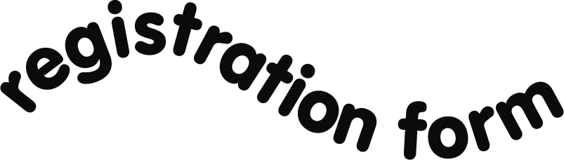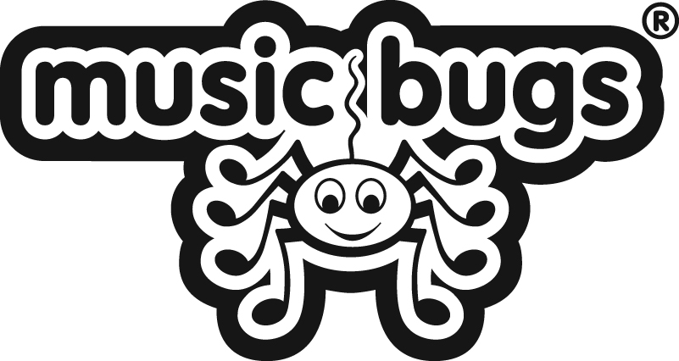
Please provide the following details:
Venue:
Day:
Time:
Your Name:
Email Address:
Telephone No: | day
 | evening
 | mobile
Postal address:
Contact: | Please indicate your preferred method/s of contact (please circle if you have a preference).  Email Home number Mobile
1st Child’s name |  |  | Age: |  | D.O.B:
2nd Child’s name |  |  | Age: |  | D.O.B:
3rd Child’s name |  |  | Age: |  | D.O.B:
Please use this space to tell us if your child has any condition such as asthma or epilepsy, or any other medical/physical condition that you feel we should be made aware of.

Please can you tell us where you heard about Music Bugs?

Please hand in this form along with your enrolment fee to your Class Leader or post to:
Rachel Dodd, 46 Cleadon Meadows, Cleadon Village, Tyne and Wear, SR6 7PJ (please do not post cash).
All enquiries to Rachel Dodd Tel: 0789 123 5086 or via email rachel@musicbugs.co.uk

Data Protection Music Bugs Ltd are committed to respecting and protecting your privacy and we will not ever pass your personal details onto a third party.
However Head Office does collect email addresses from it’s franchisees for the purposes of communication and to notify parents of special offers/freebies/news bulletins/competitions. If you do not wish to be contacted by Head Office for the purposes described above, please tick here ___
Disclaimer Music Bugs Ltd, it’s franchisees, teachers, employees or agents accept no responsibility under any circumstances for any loss (consequential or otherwise), damage, expense or delay suffered or incurred by the Parent/Carer, the child or any other party arising directly or indirectly or in any way connected
with the attendance of the child at the sessions including but not limited to, the unavailability of a teacher, ‘Acts of God’, the postponement or delay in the Course (or any part of it) or any other act or omission on the part of Music Bugs Ltd or any of its franchisees, teachers, employees or agents
By attending any Music Bugs class or event I agree to constantly supervise all the children in my care and to take full responsibility for them.
I will select age-appropriate instruments and props for my child and ensure their safe and appropriate use at all times

We would like to take photographs/videos within our classes to be used for general publicity. This might mean that the images will be used on the Music Bugs website or other websites where we advertise the Company, printed publications, training materials, newsletters, exhibition materials and also in submission to magazines and newspapers (local or national). Please tick this box if you DO NOT wish for photos of your child to be used in this context.

By allowing my child to attend any Music Bugs class or event I also agree to ensure that the correct fee (as notified to me by the Class Leader or Nursery staff) is paid promptly prior to my child attending the course.
Parent/guardian signature Date

